Food Assistance Advisory Committee Mtg
June 17th, 2021 10 -11:30 a.m.

MINUTES

- Approval of Minutes from April 15
Motion to approve: Ken Trainer, Second: Alan Hamilton, Motion passes.
- WSDA Updates (Kim)
- Fresh Boxes – WSDA, TEFAP & CFAP (see slides below)
  - WSDA Fresh Produce Boxes program
    - Formerly to end June 30, now extended through Sept 30, 2021
    - July through September snapshot:
      - 214k boxes to be distributed during this time period
      - Focus on local farms (beyond original Charlie’s Produce partnership)
      - Intended to meet COVID-based food gaps
      - Funded by $23M flexible funding for next biennium, with other USDA investments – more details to come
  - CFAP Box Program
    - WSDA working to implement new state-level CFAP program, using resiliency funding package for next biennium. Focus on non-traditional, out-of-network food assistance organizations and local farms. To begin October 2021.
      - Estimated that 75% of recipients of inaugural CFAP program were non-traditional recipients.
      - Discussion of prior CFAP program:
        - Question from Michelle re: non-traditional recipients, what does food quality accountability looks like? Saw a lot of returns to food banks. Concerned about food safety and accountability for organizations out-of-network.
          - Kim: Will outline concerns with Katie Rains and Director’s office who are looking at this specifically, believes this is being addressed. Not all prior recipients of CFAP will participate. Some accountabilities will be involved but less than that of traditional partners.
        - Trish: SKC seen many food boxes returned to food banks without clear tracking of temp controls, product had to be tossed. This topic was almost a session at WFC conference.
        - Alan: Would love to see future coordination so gaps and redundancies are reduced.
        - Kate: Non-customized boxes are often not useful to recipients.
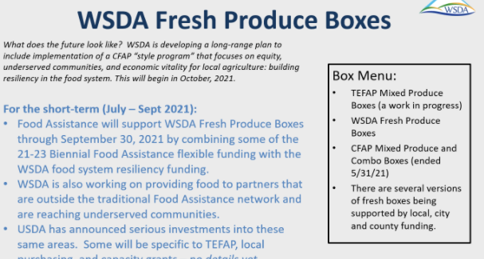

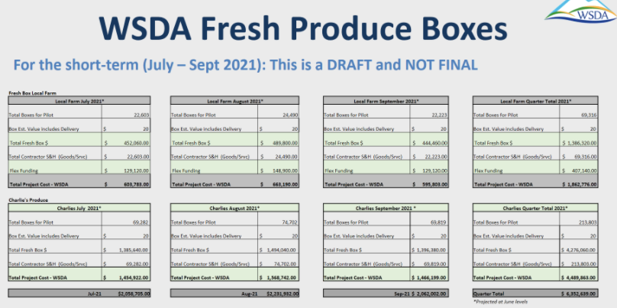
- Client Intake System
  - Digital intake:
    - WSDA not mandating switch to digital intake procedures.
    - WSDA approval not required to switch to digital intake if nothing else is changing
    - WSDA approval is required with new EFAP or TEFAP intake processes or forms
      - Request form from WSDA Regional Representative
  - Fiscal year:
    - WSDA recommends consistent EFAP fiscal year that is based on calendar year. Will help make “Is this your first visit” (duplication) question clearer and more uniform across state. Want to make the decision soon, starting conversation now.
    - OK for agencies to update fiscal year for intake processes, WSDA recommends consistency between contracts and subcontractors. Recommend extra communication during such a transition. Recognize that data may take hit during transition.
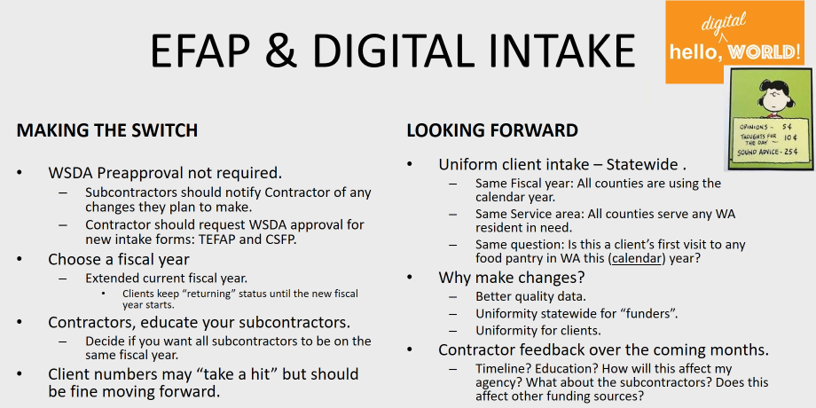

- EFAP Contracts: Contractor and subcontractor templates will be ready next week
- Funding Updates:
  - Historic funding of food system initiatives in 2021 legislative session. Focus areas: enhanced FA programs; food infrastructure; farm to school programs; capacity grants, etc.
  - WSDA Primary Objective: Ensure access to a safe and nutritious supply of food to support a healthy and thriving Washington population.
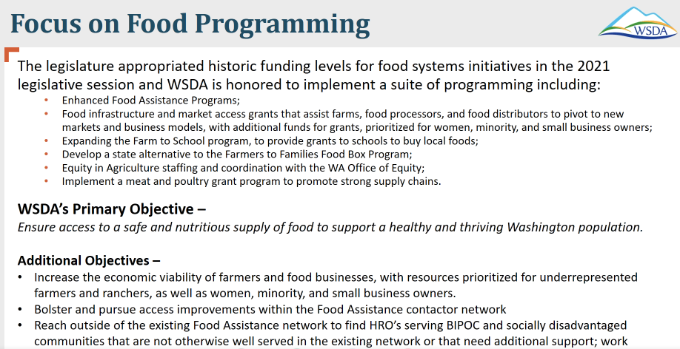
  - $27M dedicated for SFY2022 to develop state CFAP program with focus on local purchasing and culturally relevant foods
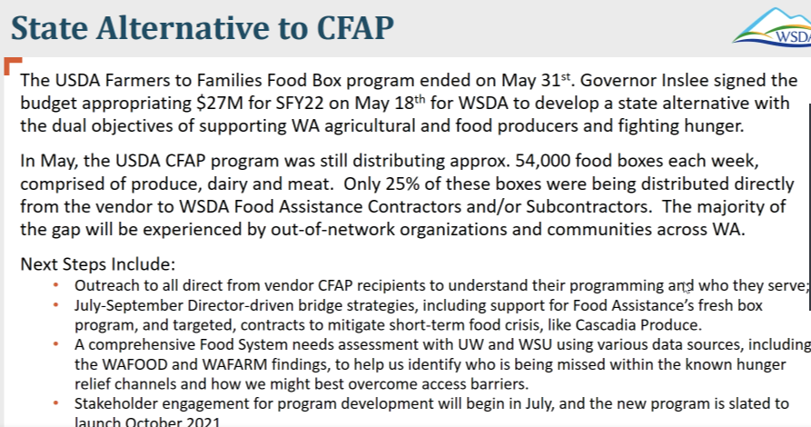

  - EFAP 21-23 Biennial Funding
    - +$4M EFAP pass-through funding
    - +$350k Farm to Food Pantry
    - +$7.2M flexible funding to fill gaps in emergency food system, focusing on:
      - Food purchasing (local, culturally relevant, etc.)
      - Strategic investments
      - Grants (filling gaps, supporting rural and BIPOC communities)
      - Expect subcommittee to help determine use of flexible funds
      - Helen McGovern will be surveying for improvements to future grants
  - USDA investing $1B into hunger relief system, 3 categories:
    - 1- TEFAP $500M
      - State share: $10.5M
      - Possible future program like TMP, based on market research
    - 2- Cooperative Grants (local purchasing) $400M, working with Tribes
      - Not competitive
    - 3- Infrastructure $100M
    - Expect more clarity Sept/Oct, with possible implementation Oct-Jan (FFY2022)
    - State determines best use of allocations
    - Client intake: USDA goal to reach non-traditional agencies; Kim recommended estimated data for non-traditional agencies, then extended to TEFAP
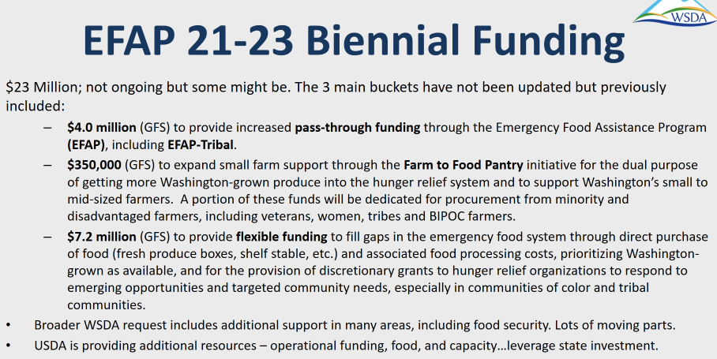

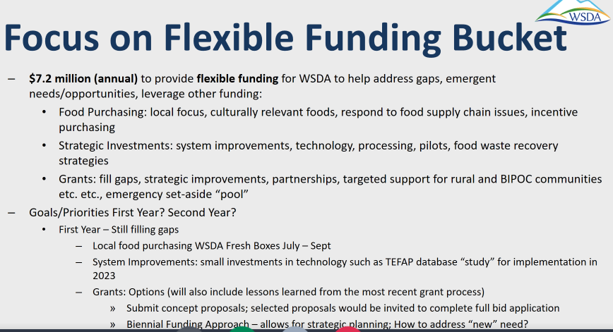
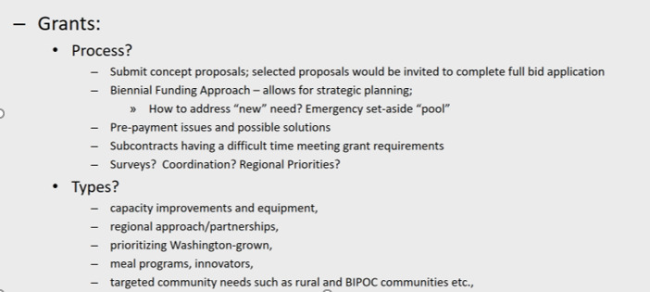

- Review work in progress
- Subcontractor Resources Task Force
  - Currently on hold
  - WFC: Food Bank Certification Course moving online with videos for all 5 session, expect by end of month; collaboration with Nancy Bacon
- Statewide Nutrition Policy – Kate
  - First meeting earlier this month, great group, seeking more participation for enhanced statewide representation
  - Email trish@wafoodcoalition.org for nutrition policy committee participation
  - Michelle requesting guidance for sourcing healthy/low-sodium foods; Trish confirmed group working on compiling resources for sourcing these and culturally-relevant foods
- Civil Right Training Update – WSDA, Mallorie
  - Reminder: due annually
  - Great opportunity to remind/update staff, volunteers, and subcontractors of new intake requirements
  - Future updates to language and to make language less “legal”

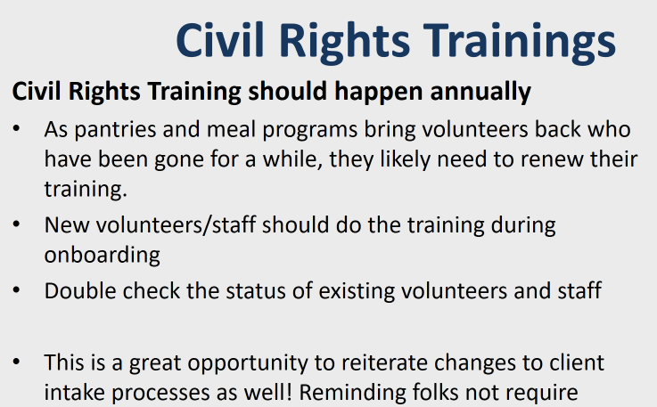

- Ad Hoc Committee on Grant Process Feedback – Michelle reporting for Robert (Thurston County), leading effort with Helen McGovern. Robert still collecting qualitative feedback on last round of capacity grants, requesting feedback from across state. Helen will be sending survey in next two weeks, please be candid in your feedback and supply any other helpful information. $100M reimbursed to date. Grant has been a game-changer for many organizations.
- Upcoming biennial – Assessing Community Needs - Michelle/WSDA
  - Kim: Recruiting subcommittee and taking volunteers to discuss future needs. Need to determine right approach (surveys, etc.)
  - Notify Kim if want to participate in subcommittee or have assessment skills to contribute. Or send feedback via email.
- In-take Requirements Subcommittee Report out – Michelle
  - Looking at laws and stature of TEFAP to understand whether address is in intake requirements; letter sent to USDA for clarification. Committee on hold until response from USDA received.
  - Had recent conversation with reps from Eastern WA, Spokane region, 2nd Harvest, Food Lifeline, re: collecting zip codes in areas where they cover substantial areas
  - “Unduplicated” question: ongoing conversation, more work to do, confusion remains re: what it means
  - Asking for or requiring ID: ongoing discussion re: how to monitor on the ground operations and advance initiatives to remove
  - Natalie, Spokane: manages SNAP education program for region; request for grants to emphasize equity in food banks and help remove barriers to food service
  - Brittany, Community Action Council in Wenatchee: switching to “Link2Feed” to streamline information; concerned that federal funding streams have different requirements, can cause confusion/frustration for agency and clients. Michelle suggests separating funding and services wherever possible to reduce barriers to low barriers services such as food.
  - Expect more conversation on this evolving topic.
- Compliance Review questions - WSDA
  - We are all still obligated to complete compliance reviews, severely behind
  - Template provided by WSDA, revisions can be made (WSDA approval required)
  - WSDA regularly updates forms prior to reviews for opportunities to be more educational and supportive of agencies (education emphasized over punitive action). Haven’t had opportunity to do so recently.
  - WSDA recommends contractors use the following questions as launching points for discussion to ensure compliance and consistency with subcontractors and alignment with current guidance:
    - 1- 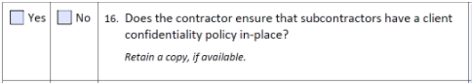
    - 2- 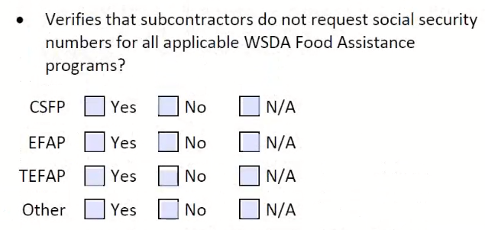
    - 3 - 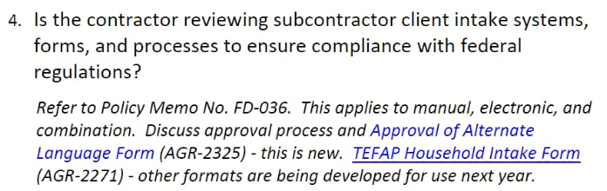
  - Kim requesting input on contract compliance monitoring questions via email, and volunteers to take part in discussion next week (contact Trish if interested)
  - Contractors: be prepared to share with and answer questions from subcontractors
- WFC Conference, 9/29 -10/1/21 – Trish
  - Hybrid model, in-person in Wenatchee and live-streamed
  - Theme: “Hindsight is 2020, but the future is filled with possibilities”
  - Requesting conference training topics & speakers (send to Trish)
    - WSDA, Kim: What can Food Assistance do, what training topics are desired, discussions/Q&A facilitated? Want to add value to conference
    - Ideas shared: Microagressions and deeper understanding of historical and sytematic inequities throughout our food system as well as Social Determinant of Health; trauma-informed approach to service
- Michelle: Send ideas and topics for this group to discuss. It’s our group!
- Good of the Order
  - WFC Board Meeting, June 30th
    - Open meeting; if want to join, email Trish
  - Contractor Calls (2x/month); next call: June 25th 9-10 a.m.
- Open Discussion: no topics raised
- Thank you for your time, take care all! Meeting adjourned at 11:24am.

