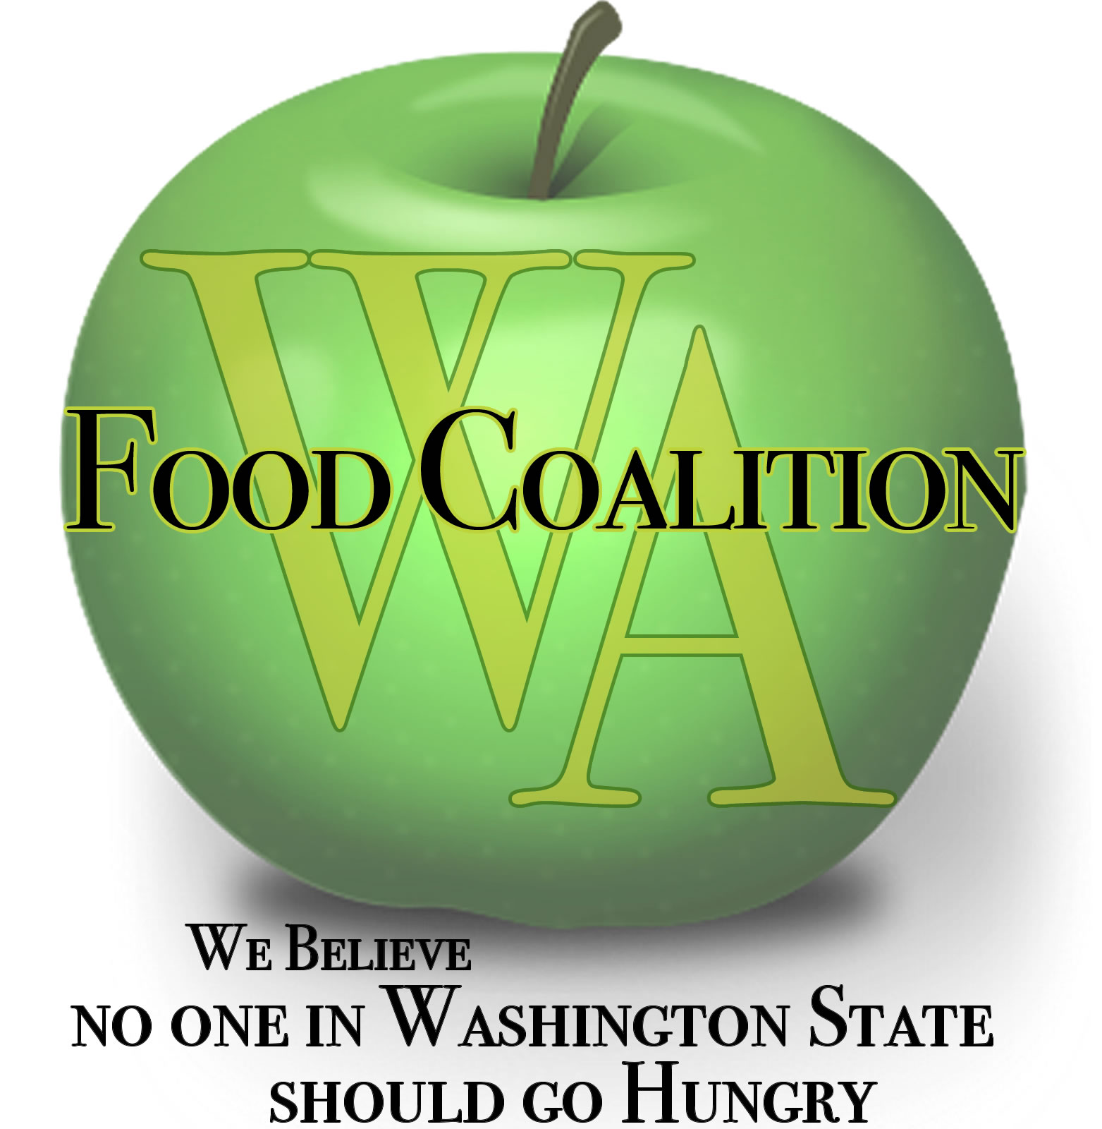
Washington Food Coalition
www.wafoodcoalition.org
PO Box 95752
Seattle, WA 98145
phone: 206.729.0501
fax: 206.729.0504
info@wafoodcoalition.org

Minutes for the FOOD ASSISTANCE ADVISORY COMMITTEE MTG

April 11, 2023

Attendees:

Michelle Douglas, Chair
Mike Cohen
Joe Gruber
Claire Lane
Nikki Loyd
Brian Taintor
Erin Longchari
Peny Archer
Bob Mark
Ken Trainor
Sara Benner Kenagy
Emily Heemstra
Mike Hatada
Kris Van Gasken
Rachel Bishop
Rena Shawver
Yamila Sterling
Jay Kang
Eric Williams
Amelia Calhoun
Trish Twomey

WSDA Staff:

Kim Eads
Mallorie Shellmer
James Scovel
Anna Berry
Lisa White
Heidi Cobun
Erin Kesler
James Scovel

Welcome / Introductions
Approval of Minutes from January 17, 2023, meeting.

Early Action Funds (HB1784) Update – WSDA $20 M Total; End Date June 30,2023
$10 M to Director Designated Emergency Awards (TBD)
$10 M to Food Assistance (FA)
- $5 M through FA for food purchase
  - Goes out through the Reserve Warehouse, TEFAP Lead Agency Model, but not restricted to food distribution to only TEFAP Sub Agencies
  - Purchased thru US Foods, some local contracts
  - Who determines what is purchased? Food Ordering Workgroup (meeting coming up in the next few weeks) & Availability of types of food. To join the workgroup, contact James Scovel -jscovel@agr.wa.gov

- $5 M – EFAP and EFAP Tribal Increases for SFY 2023 (this current year)
  - Projections sent last week along with spenddown confirmation request
  - Any funds not accepted will be put towards food purchases
  - Flexibility given to Lead Agencies to use the funds as able or most needed within the timeline given
  - Must be spent by June 30, 2023; exception to delivery of food may be allowed (maybe July and early August)
    - Note: It was clarified after this FAAC meeting that there would be no flexibility to receive goods after June 30th.
  - May be used for bills incurred previously; retro-active to July 1, 2022
  - Food, operations, staff, critical and immediate needs etc.

WSDA Updates – Kim Eads
EFAP Update – Q & A Sessions are being held on Tuesdays, 9-10 a.m. until the end May to support Lead Agencies, Sub Agencies, and Interested Parties through the EFAP Biennial Meeting and Application process.

- Requested ad-hoc committee to review Procedures Manuals, forms & other materials. Feedback is welcome, and concepts and intent within the manual are not changing.
  - Trish will send an invite to try to meet and review for feedback, or you can choose to participate via email. This is a 100+ page document and it is recommended to focus on topic areas such as Client Intake, explanations of fiscal policies, etc.
    - Emily from CCFB, Mike from Hopelink, Erin from Issaquah FB, requested an invite
    - Recommendation: This committee should include/be available for Sub Agencies and not just Leads. Michelle confirmed that multiple invitations for feedback have been offered to Sub Agencies as well. At this point, anyone who has feedback is welcome to provide it.
- Forms & Draft Procedures Manuals: https://agr.wa.gov/services/food-access/hunger-relief-agency-hub/fa-forms-and-pubs
- Recommendations, Lessons, Next Steps: Feedback is important – don’t hesitate to reach out. We’ve heard: digital intake - changes take time, site visit flexibility afforded, concerns about impacts on other programs.
- Clients and Service Area: 2021 Guidance doc, this was understood as no big deal. 2023 Procedure Manual and Agreement updates – understood as a big deal. Inventory down, demand still high. Concerns & uncertainty.
- EFAP Closeout: Tribal due August 1st, Non-tribal (+ STOWW&SPIPA) due August 15th – State and Federal. Fillable subcontractor closeout report is available online. Follow up with your EFAP Lead Agency for a due date to them.
- EFAP Spenddown: 6/30/23. Other funding sources that expire too: EFAP State, EFAP Federal, TEFAP GAP (supplemental), CSFP GAP (supplemental), Resiliency Grant, Crisis Funds, Early Action*. Invoices to date (all FA funding sources)

Questions during WSDA Update:
- How do I know how EFAP Early Action Funds are being spent in my community? Reach out to your EFAP Lead Agency to learn about how pass-through funds are being spent (if accepted). For access to Reserve Warehouse food purchased using these funds, follow up with your TEFAP Lead Agency.
  - These commodities can go out to any food pantry or Meal Program in your county, not only those participating as TEFAP Leads.
- When can we expect to see these Reserve Warehouse commodities delivered to TEFAP Lead Agencies? Immediately – there is a purchase wrapping up from existing funds. With the (new) additional Early Action Funds, the commodities will be delivered in July and August and depend on delivery times and availability through US Foods.
- What resources can Meal Programs access from these Early Action Funds? Meal Programs AND Food Pantries can receive the Reserve Warehouse Commodities. The EFAP Early Action pass through funds is only available to existing EFAP and EFAP - Tribal Food Pantries (Meal Programs do not participate in EFAP)

Request for FAAC – TEFAP Client Income at Gross (before taxes) or Net (after taxes)?
- The committee Recommended Net Income. No one indicated they thought that Gross Income would be more ideal. No reason to convene a subcommittee because of the unanimous nature of the comments. Both chat and verbal space was given for dissent.
- Passed: TEFAP Income is passed based on Net Income

Next Biennium Projections
- FA Budgets, including Resiliency Grants
  - Will there be minimum and maximum request amounts for Resiliency Grants this time around? Answer: It is being considered. No decision was made at this time.
- We Feed Washington
  - Reduction is very likely. There is a big difference in the funding included in current House and Senate Budgets in the Legislature.
$30 M
2024 - $15 M; all federal
2025 - $15 M; mix of state and federal

Funding buckets - Annual $15 M
- $5 Food purchases
- $4 to 5 M for Resiliency Grants (last year $16.1 M) (includes small grants managed by HAH)
- $3.76 M for EFAP and EFAP Tribal (mix of State and Federal)
- $1.24 M Flexible Crisis & FA Operations
Food Assistance Biennial Budget – Things to know.
- Make request a Supplemental Budget net year
- Proviso Possible – EFAP Essential Nonfood limit increase from 10% to 25%
- Issue - looks like it is not all on-going; only portion of State funding (?)
- F2FP, TEFAP Gap, CSFP Gap will still be supported with the use of other funding.
Claire shared that getting a Supplemental Budget request had very low chances of getting approved. The House budget is the high-water mark.

Michelle asked if those on the call, who have networks, could get the sign on letter out ASAP. Closes tomorrow.

What’s going on in the System?
What’s ahead? Innovations
Michelle wanted to hear from programs on the call about any innovative things they are doing to bring in more food. She shared that EFN is selling their extra pallets to raise funds to purchase food.

Trish asked those on the call to share where they are purchasing food from. Folks responded with various wholesalers such as Charlie’s Produce the Weigelt Company, QFC, Safeway, Franz, Springbrook, WinCo, Fred Meyer, UNFI, US Foods Puget Sound Hub and Dairy Valley.

Trish shared about the Compliance Training on receiving State and Federal funds, April 19th.

Good of the Order:
Lead Agency Calls – April 7th, 9 a.m.
General Focus Calls – April 18th, 9 a.m.
Q & A Sessions, Tuesdays, 9-10 a.m.
WFC Board Meeting – April 26th 1-3:30 p.m.

2:30 Close

