Food Assistance Advisory Committee Meeting
January 17, 2023
Michelle Douglas, Chair, asked those on call to introduce themselves and their organization.
- Present:
Trish Twomey, WFC; Michelle Douglas, EFN; Ken Trainor, SOC; David Uhl, Feeding Washington; Mallorie Shellmer, WSDA Food Assistance; Taelor Nguyen, WSDA Food Assistance; Rick Lewis, The COVE; josh martinez, Future Emergent; Kim Eads, WSDA Food Assistance; Rachel Bishop, Upper Valley Mend; Rebecca Schlaht, Helping Hands; Jen Muzia, Ballard Food Bank; Heidi Cobun, WSDA Food Assistance ; Fran Yeatts, West Seattle; Lindsey Robinson, WSDA Food Assistance; Tom Garstki, SVDP Longview; Sam Cook, EFN; Patrick Merscher, WSDA Food Assistance; Kyle Merslich; WSDA Food Assistance; Andra Smith, Sequim Food Bank; Erik Mora, BMAC; Mikel Priddy, EFN; Jody Stoltz, Tenino Community Service Center; Isaac McKenzie Sullivan, TCFB; Stacey Crnich, Bonney Lake Food Bank; Brent Derocher & Kieran Collins, Clark County Food Bank; Kate Ortiz, Public Health Seattle & King County; Missy Belles, Whatcom Community Foundation; Amelia Calhoun, Feeding Washington; Felicia Kolhage, SVDP Bremerton; Linda Rapozo, EFN; Paige Collins, COAHS Colfax; Jennifer Milnes, 2nd Harvest; Mike Cohen, Bellingham Food Bank; Brent Hunter, Coastal Harvest; Timothy Eisbree, The Salvation Army; Anna Berrey, WSDA Food Assistance, Emily Heemstra, Solid Ground; Erin Kester, WSDA Food Assistance; Barb Shimizu, South King County Food Coalition; Emily Straw, Clark County Food Bank; Nikki Lloyd, Snoqualmie Valley Food Bank; Bob Mark, Upper Valley Mend; Terra Hegge, TCFB; Aja Bridge, RRCA; Deborah Ornellas, WSDA Food Assistance; Kayla Jacobson; Deborah Demps, Paradise of Praise Food Bank; Lisa Blaine, Lower Columbia CAP; Patti Nichols, WGAP;

- Approval of minutes
December 6, 2022, meeting minutes
Ken Trainor moved that the minutes be approved. David Uhl second the motion.

- Client In-take Subcommittee Updates – Trish Twomey and Mallorie Shellmer
A survey regarding EFAP data collection was sent out to EFAP contractors and subcontractors on January 3, 2023. As of this meeting, there have been 112 surveys submitted. The next step is to compile all the data collected and share results with WSDA and this committee.

- Emergency Food Assistance Program Recommendations – josh martinez
josh martinez, with his company Future Emergent, was hired by WSDA to take a deep dive into EFAP and discover what improvements can be made to make it an all-around more equitable program. This is important because food insecurity levels keep increasing, and there are still stigmas around using foodbanks. josh has met with approximately 20 EFAP Contractors within the network, with plans to meet with more, to compile a current state of EFAP.
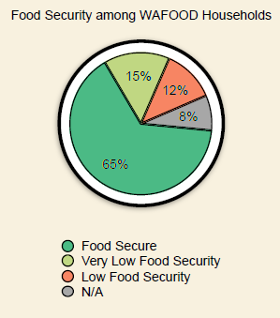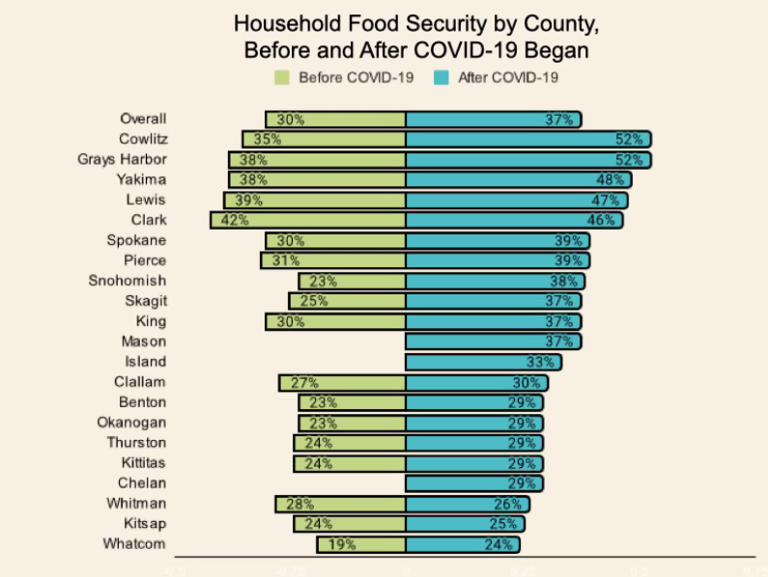
Current State – Likes and Pain Points
What People like:
- EFAP is flexible in comparison to other programs – All food-banking related expenses are acceptable.
- EFAP is like having “emergency savings” – Contractors hold funding and reimburse expenses from subcontractors.
- Spring meetings are a great time to connect – Subcontractors across the region can gather and plan together for the coming biennium.
Pain Points
- Changing food systems – New ways of distributing food, increased food insecurity rates, outdated approaches to service.
- Variations among contract regions – Each region has different expectations for how to administer EFAP and meet community needs.
- Competition among food pantries – Allocations with limited EFAP dollars can get contentious.
- Turnover among staff – New contractors, subcontractors, and organizations disrupts institutional knowledge.
- Inconsistent data – Every region, food bank, or pantry may collect data slightly different.
- Entrenched power systems – organizations with large budgets or long histories maintain the status quo.
Recommendations
Values:
- For the 23-25 Biennium – Food needs to be addressed as a human right; We need to talk about how much food systems have changed; Who are the people that don’t feel covered by our services? Why is that? Ensure fair and nondiscriminatory access to all hunger relief organizations in Washington State.
- For the Next Biennium – Set service expectations for all EFAP recipients; Fund food assistance to include new models and approaches.
- Long-term Actions – Engage with community members on an ongoing basis; Signage for all languages in the community; Engaging with community members in a new way; Shift our approaches away from a charity model towards a social justice model; Think about food insecurity in our community. How are (or aren’t) people getting their needs met? How do we know?
Funding:
- For the 23-25 Biennium – Offer incentives to programs that expand community access, decrease food insecurity, or remove stigma from food banking; Standardize new/returning data collection across the state.
- For the Next Biennium – Clarify the purpose of EFAP funding; Shift funding away from organizations that do not meet the needs of their community.
- Long-term Actions – Consider the impacts of expanding our service areas to the entire state; Organize all community-facing food assistance and simplify how we fund our programs.
Contracts:
- For the 23-25 Biennium – Standardize terminology; Update service areas to include county “and surrounding areas” for all Washington residents.
- For the Next Biennium – Set minimum expectations for EFAP funding; Reduce the collection of personal information as much as possible, make all programs self-attesting; Update audit process to include accessibility, nondiscrimination, and community engagement questions.
- Long-term Actions – Write EFAP contracts in plain language; Rewrite sections that are unclear to readers.
Spring Meetings:
- For the 23-25 Biennium – Clearly define service duplication statewide, collect hours/days open for all EFAP agencies; Create a Spring Meeting template with all required information; Set expectations for EFAP applications presentations.
- For the Next Biennium – Create a statewide list of EFAP-eligible hunger relief organizations; Expand voting memberships beyond subcontractors; Create templates for possible allocations models, request a narrative for how/why the region allocated funding the way they did.
- Long-term Actions – Conduct visioning and strategy sessions with all EFAP recipients in a region. What could food assistance look like in the future?
Training:
- For the 23-25 Biennium – Offer trainings for all EFAP subcontractors, contractors and distributors, and interested parties; Create executive summaries for change to EFAP contract since last biennium.
- For the Next Biennium – Provide sample scripts and trainings for volunteers and staff to use the new messaging.
- Long-term Actions – Think about how we can create or expand collaboration and sharing networks across the state; How can we invite new programs to join our efforts?

- Other Updates

Spring meetings – When are your spring meetings scheduled? Are you planning on a virtual or in person format?
WSDA Updates – Kim Eads – The legislative session is coming up. Attached to these notes will be the legislative agenda. For questions about Food Assistance specific legislation: keads@agr.wa.gov
Good of the Order:
Contractor Calls – February 3rd @ 9:00 to 10:00 – TEFAP Contractors Only
General Focus Calls – February 21st @ 9:00 to 10:00
WFC Board Meeting – January 26th 1-3:30 pm
Hunger Action Day – February 7th

