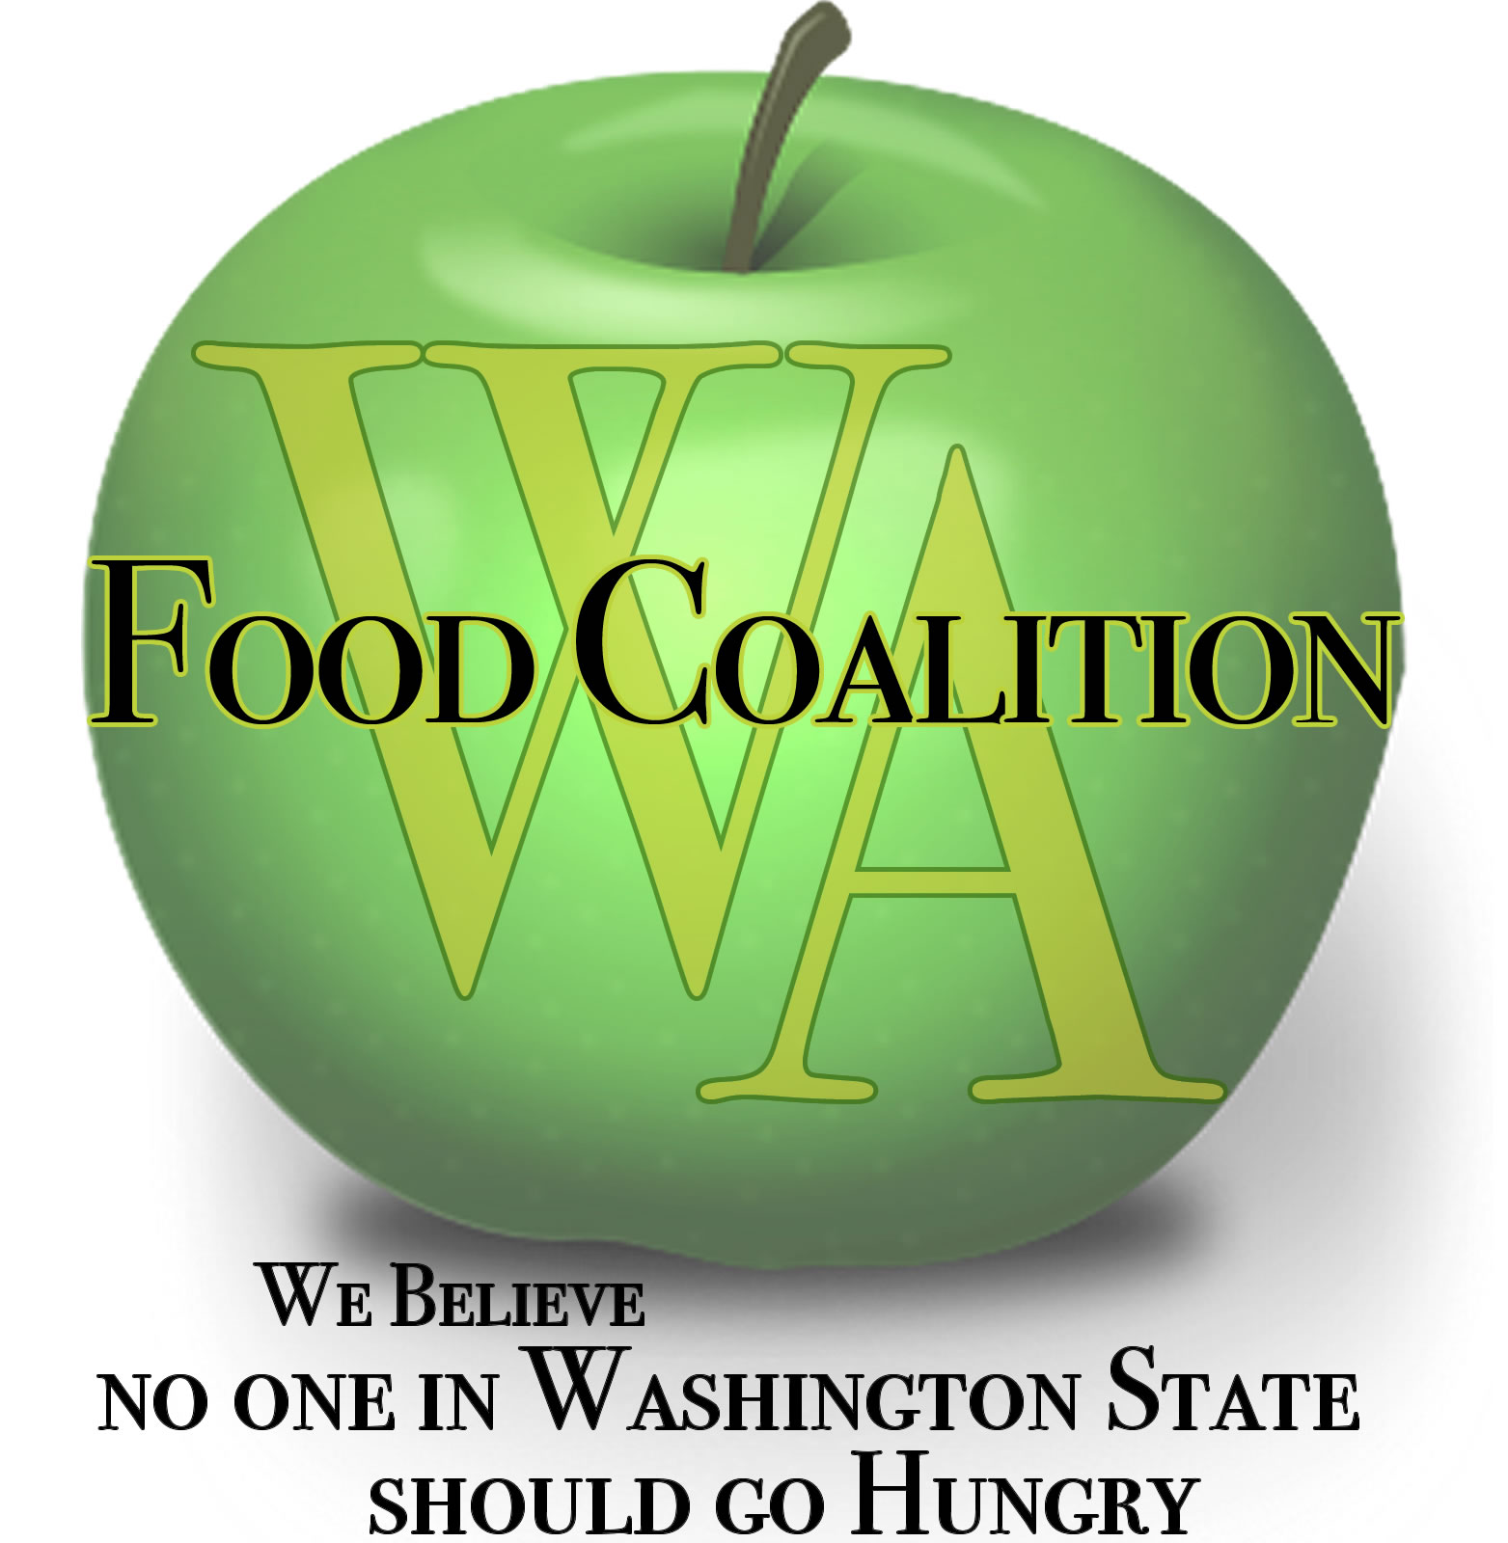
Washington Food Coalition
www.wafoodcoalition.org
PO Box 95752
Seattle, WA 98145
phone: 206.729.0501
fax: 206.729.0504
info@wafoodcoalition.org

Food Assistance Advisory Committee Mtg
April 12, 2022 9-10:30 a.m.

AGENDA

9:00 Welcome / Introductions –Please share your name, organization. Are you new to your position in the last three months, if not, how long have you been in your role?

9:20 Approval of Minutes from January 26th, 2022 meeting. We need a secretary!

9:25 WSDA Updates – Kim Eads
- TEFAP Food Ordering Committee Update (July – Dec.)
  - Update on upcoming products
  - TEFAP Mixed Produce Boxes
    - We Feed WA Boxes
- Food and Funding All Sources Update
- Flexible Funding Grants Update
  - Introduction for Grant Round 2 – April 18th
    - What’s working well
    - Identified issues that were challenges – changes to application
- Compliance Review Updates
9:55 Review work in progress:
- WSDA Subcontractor Resources Task Force - On hold
- Statewide Nutrition Policy – Trish

10:00 Discussion topics:
- Client In-take Subcommittee Updates
  - TEFAP Income Guidelines Conversation
  - TEFAP ID and form changes
  - Ongoing conversations on Duplicated and Unduplicated
  - Subcommittee Meeting report out
- What do people need going forward?
  - Support and Sustainability
  - Trends for 2022, what have you noticed?
- WFC Conference updates, April 21 & 22nd, Wenatchee, WA
10:25 Good of the Order: Contractor Calls - Next call: May 6th at 9 a.m.
Contractor calls are meeting once a month.
General Focus Calls – Next call: April 19th, 9 a.m.
General Focus calls are meeting once a month. WFC Board Meeting – Hybrid meeting -April 21st at 9 a.m.

Future dates for the Food Assistance Advisory Committee and WFC Board Meeting
  - Wednesday, July 26th
  - September 28th
  - January 2023
10:30 Close

