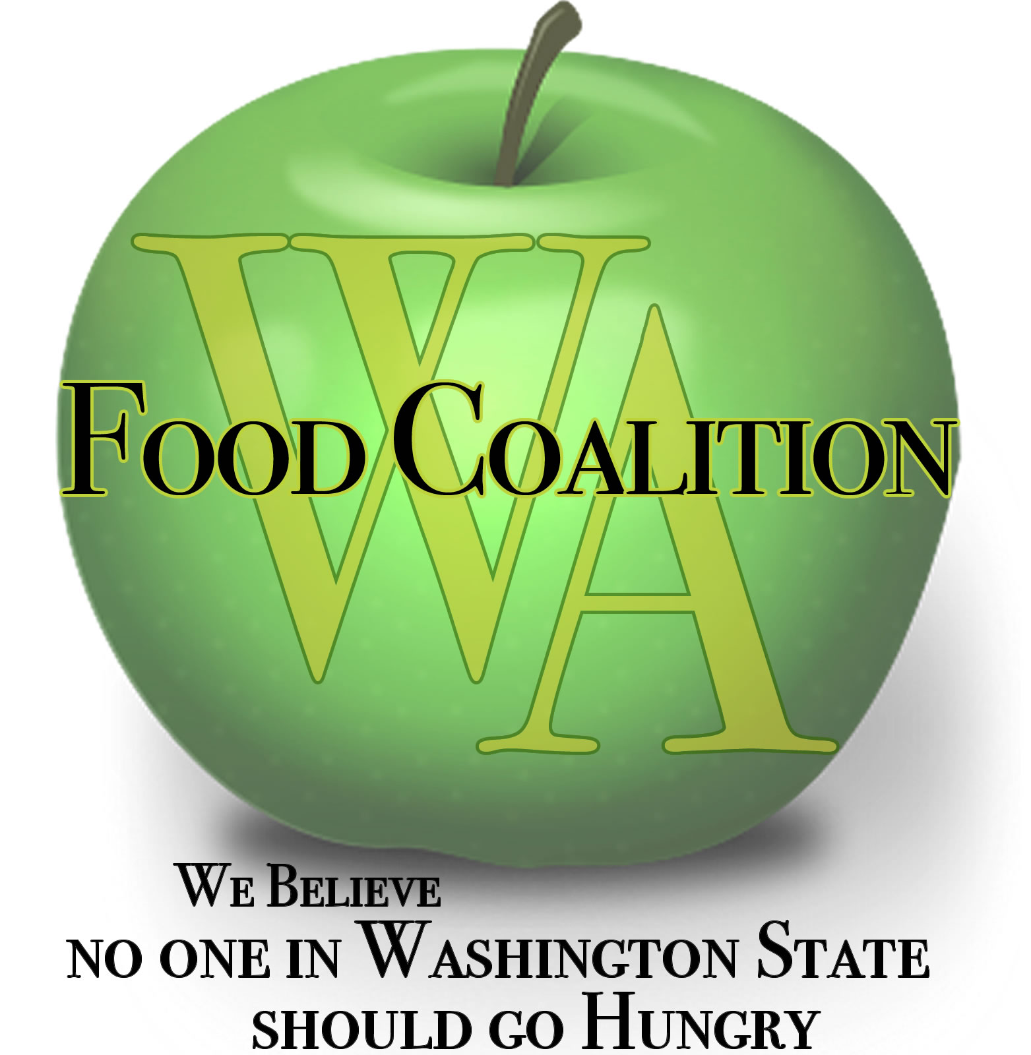

Food Assistance Advisory Committee Mtg
August 24, 2021 1 -2:30 p.m.

MINUTES

Attendees: Michelle Douglas, Chair, Bob Mark, Christina Wong, Emily Straw, David Bobanick,
Mariela Barriga, Amelia Paul, Stephanie Watson, Dana Cordy, Claire Lane, David Uhl, Emily Kanally, Kate Ortiz, Peny Archer, Ahndrea Blue, Alma Castillo, Stephanie Sherry, Trish Twomey
and Aaron Czyzewski

WSDA Staff: Lindsey Robinson, Kim Eads, Mallorie Shellmer, Nichole Garden & Lisa White

Welcome / Introductions

- What is changing for you with Governor’s mask mandate and raising Delta variant activity?
  - Emily Straw, Clark County FB: back to masking, haven’t changed operations, drive-through and grocery-style models
  - Christina Wong, NWH: SODO Community Market using pass-through windows rather than in-person; mask policy re-instated (before mandate kept vaccination status log)
  - Michelle Douglas, EFN, Pierce County: 3 shopping types available – in-person, hybrid, outside service; masks mandated
- If you have supply needs (PPE: sanitizer, gloves, masks) reach out to Trish Twomey
- Claire Lane (chat): We should be clear with organizations that, as of yesterday, EVERY program must require masks indoors.
Approval of Minutes from June 17th Meeting

Motion made by Peny Archer to approve the minutes. It was seconded by David Bobanick. Approval of Minutes passed.
WSDA Updates – Kim Eads

Supplemental Budget Request Update: Moving forward with a concept proposal
- Received $23M, which is incredible but did not include everything. Moving forward with Supplemental Request in 3 areas, knowing that things may change:
  - 1 - Increase for Fresh Boxes/local produce
    - Pending Food Assistance Fresh Box/Bulk Survey – due COB August 25, 2021
  - 2 - Increase for Capacity Grants
    - Pending Capacity Assessment Survey with HAH (Primary) and UW (Advisory)
      - Should be open Sept. 1 through Sept. 17
      - Broad outreach
  - 3 - Emergency Management Reserve
    - PPE, Water, Transportation, Other
Question from Christina Wong, NWH: Update on $45M funding? How is information from this survey informing next steps?
  - Kim Eads, WSDA: Supplemental budget is specific to WSDA Food Assistance requests but will be coordinated with the WSDA CFAP Alternative Box program. There is Legislative funding designated for creating CFAP alternative program (looking at programming), with intention to reach groups outside existing network. Agency working with UW to survey gaps to address, expect more results in September. Overall $ amount still may not be sufficient to meet existing needs.

Flexible Funding Grants Subcommittee:
- Received capacity funding from legislature: $3M in flexible funding grants this SFY (2021-2022); $6M+ for biennium
- Formed Flexible Funding Grants Subcommittee:
    - Representation across Washington in multiple sectors: Rural, urban, contractor, subcontractor, advocacy, meal programs, etc.
    - Weekly meetings Aug/Sept to launch applications asap (Fall 2021)
    - Proposed 3 Grant Types (includes opportunities for organizations outside of FA network):
      - Food Distribution Efficiencies (staffing, capacity improvements, equipment, etc.)
      - Target Community Needs (meal programs, BIPOC, homelessness, veterans, rural culturally relevant foods, etc.)
      - Pilot Projects, Innovation, Food System Improvements (local purchasing, regional approach/partnerships, home delivery, food processing, etc.)
    - Significant outreach efforts to extend beyond regular hunger relief network.
- Incorporating process improvement feedback from surveys & ad hoc committee
    - Timeline requests: 30-45 day application period; 8+ months spending period
    - Looking to bring on an organization to help coordinate accounts with non-contracted agencies, and support funding efforts
- Remind your networks to get their SAM and DUNS #s in advance
- In progress: mission/vision statements; grant objectives; workgroups; process improvements
- Much more to come! Information will be posted on the WSDA FA website

Feedback on WSDA Conference Session Topics:
- Reducing Barriers to Access – Review Guidelines for EFAP, EFAP-Tribal, TEFAP and CSFP; Panel discussion with contractors/subcontractors implementation strategies
    - Client Intake
    - Service Areas
    - Next Steps
- Future Grants – Assessments; Process Improvements; Target Areas (not just infrastructure); FA Flexible Grant Funding Subcommittee; Eligibility; and Things to Know before Applying
    - WSDA FA Flexible Grant Funding 2021-2023
      - SFY 2022 (July 1, 2021 – June 30, 2022)
      - September/October Applications
      - October/November Selection of Grant Awardees
      - Grant Completion June 30, 2022
      - SFY 2023 (July 1, 2022 – June 30, 2023)
      - April Applications
      - June Selection of Grant Awardees (Projects begin July 1, 2022)
      - Grant Completion June 30, 2023
    - 3 - USDA TEFAP Capacity Grants - TBD
      - FFY 2022 (October 1, 2021 – September 30, 2022)
      - Looking at options to supplement WSDA FA Flexible Grant Funding
      - May set-aside partial funding to support TEFAP Database
      - May set-aside partial funding to support TEFAP contractors and subcontractors (funding via contractors) smaller equipment needs
- Food Update – What food is coming into the system (James Scovel)
Christina Wong (chat): I would also love to see a session [at WFC conference] give time for brainstorming or talking about existing examples of what might be the creative partnership that contractors can do to use the resources available in flexible grants to build partnerships with schools and other community-based efforts that can coordinate to increase food access.

General Funding Update:
- SFY 2022 EFAP and EFAP-Tribal – make sure you have a spending plan now to spend down all funds by June 30, 2022.
  - May include revising EFAP plan, may include talking w/ subcontractors re: use of funds.
  - Last year we had turn-backs due to lack of planning.
- FFY 2022 TEFAP – In addition to regular “TEFAP”:
    - Confirmed New Funding:
      - FFY 2022 - $500 Million TEFAP
      - $100 million TEFAP Operational Funding
      - $400 million TEFAP Food & possible option to shift some to funding
      - 2.11% WA Share Estimate
    - Pending New Funding:
      - $100 Million Capacity (TEFAP Infrastructure?)
      - $400 Local Food Purchasing
- FFY 2022 CSFP – Similar levels but our caseload is down which determines the budget
    - May need to request an increase just to maintain FFY 2021 levels
    - USDA is considering an exemption to the 95% requirement in order to request additional caseload
Fresh Boxes:
- WSDA Food Assistance Fresh Boxes through September 30, 2021
    - May be able to extend a little longer to rural and tribal organizations
- TEFAP Mixed Produce
    - As is through September 30, 2021
    - Reduced levels (by choice) October – December
      - USDA awarded an Illinois vendor the WA contract
  - We will wait to determine if we will order January - March
- WSDA CFAP Alternative
    - WSDA roll-out in October
    - RFQ K3578 is now open; Katie Rains is the lead on this; all questions go to wefeedwa@agr.wa.gov
      - The We Feed WA Pilot Food Program has two primary objectives:
    - Increase the economic viability of farmers and food businesses through the procurement of emergency food from Washington-based farm and food businesses, with resources prioritized for underrepresented farmers and ranchers, as well as women, minority, and small business owners.
    - Increase emergency food access among BIPOC and socially disadvantaged communities that are not otherwise well served by the existing WSDA Food Assistance network or that need additional support by leveraging unique distribution models or relationship networks that overcome identified access barriers.
    - Michelle Douglas: Are we anticipating participation to be mostly rural and underserved communities?
    - Kim Eads: We hope those that serve or have plans to serve those areas will apply.
- Link to RFQ from Katie Rains

Dana Cordy (chat): You mentioned USDA will stop forcing contractors to take TEFAP product - when will that change begin?
  - Kim Eads: This message is coming from WSDA FA team, not USDA. Please don’t limit your distributions, give as much out as is needed by your communities and other outlets to keep supply moving.
TEFAP Risk Assessment: Heads-up planning for Survey Monkey TEFAP Risk Assessment in January

TEFAP Supply Chain Issues: Bottlenecks and Supply
- Here are a few things we are considering:
    - TEFAP Reserve Food: Stop pushing this product (hold it longer on our end)
    - Reduce the amount of food we order; possibly target highly desirable foods
    - Do not take all the “bonus” food that is offered
- USDA foods are still getting canceled due to a lack of vendors bidding
    - James Scovel will give a more in-depth update at the next meeting
Review work in progress:
- Subcontractor Resources Task Force - on hold
- Statewide Nutrition Policy – Kate Ortiz
  - Kate Ortiz, workgroup member: working on purpose of a nutrition policy at WFC level and identifying goals; robust conversation; still inviting others to join; goal to create draft policy to share at WFC conference in September to get membership feedback to help shape final policy
  - Michelle Douglas: add name/email to the chat if interested in joining!
- Ad Hoc Committee on Grant Process – See attached report
  - Community input on previous grant processes; feedback being rolled into current grant processes; thank you for this valued input!
  - WSDA also created survey for more input that is being incorporated into current processes
- Capacity Grant Improvement Survey report – See attached report
- Harvest Against Hunger Update – David Bobanick
  - Farm 2 Food Pantry:
    - Applications finalized in next month. David to work with Nichole, WSDA to roll out.
    - Goal to have in all WA counties – possible with current increased funding. Different regions use different models, sharing in.
    - Revising funding year from calendar year to fiscal year.
    - Goal to explore flexibilities within the program, whatever agencies need, such as more winter purchasing.
  - Capacity survey:
    - Process has been fast-tracked. Pilot testing survey next week, reaching out for feedback. Goals: easy-to-answer survey with meaningful data.
    - Timeline: Survey will be opened September 6 for 2-3 weeks, then process data and hope to have preliminary analysis the week of Oct 4. Draft report October 18. Final report late Oct/early Nov.
    - Claire Lane (chat): Thanks for pilot testing a survey – that’s fantastic!
    - Britany Meiklen (chat): How will these surveys become available? Via email to contractors?
      - David: Surveys will be sent out to contractors and subcontractors through WSDA.
      - Claire Lane (chat): What “contractors” and “subcontractors” are you sending this to?
        - Kim: Will send to all EFAP contractors, but it is not on contractors to enforce sub participation.
        - David: Appreciate contractor support. Also reaching out specifically to meal programs.
    - Michelle: Is there a list of participants of previous CFAP programs to send this to?
      - Kim: Yes Katie has that list, will receive survey and RFQ.
    - Stephanie Watson (chat): Be aware not all those distributing CFAP box recipients were distributing responsibly or giving out free of charge as there was no accountability in original distribution of that program.
    - Peny: Concern over storage of fresh product from previous CFAP program. Are there provisions to ensure this product is stored safely and ensure protection for our clients?
      - Kim: Katie is building food safety into RFQ, and RFQ applicants will be reviewed for food safety.
    - Claire Lane (chat): A lot of that program was just a mess… That’s why the legislature allocated $45M for an alternative here in WA

Discussion topics:

- In-take Requirements Subcommittee Report out – Michelle
  - Initial response to remove the collection of addresses for TEFAP
  - Kim: Food & Nutrition Service, Western Region. Next, policy discussion with DC headquarters to determine what we change if determined we don’t need to collect household addresses. Will discuss with contractors, there is both support and concern over change.
- What do people need going forward?
  - Smoke and Heat Policies – How are you handling it?
    - Michelle: Keeping canned foods cool. Changed farm hours to 6-2 to avoid intense weather. Offered all KN/N-95; bought respirators. Fire over weekend, immediately put in smoke policy.
    - Stephanie (chat): Where we are smoke has not been bad, heat was a challenge, did training for staff on heat stroke awareness and had water, cooling stations and shade pop canopies for our volunteers
    - Aaron Czyzewski, Food Lifeline: During distribution, applied mandatory breaks to make sure people maintained self-care.
    - Kim: Water was hard for homeless populations to get for a period and so started a water reserve in response.
      - Michelle: This was first time agency had to purchase water, was expensive/hard to get. Distressing we were ahead of Emergency Management in response. Seems evident we need collective, long-term emergency water plan.
    - Mallorie Shellmer (chat): Kim had WSDA staff go through a smoke-safety training (PowerPoint). Also have N95 masks available.
      - Britany Meiklen (chat): Can you share link to smoke training, please. Smoke Training
    - Nichole (chat): Check this site for air rating. Higher than 151 should prompt masks.
  - PPE
    - Stephanie (chat): We always need [PPE] as we are in the 5th wave.
    - Nichole (chat): KN95 or N95 recommended.
    - Peny: Will likely have future need, though currently unknown.
    - Stephanie (chat): Gloves and N95 masks if we can get them per recommendation of CDC for Delta.
  - David (chat): Has anyone partnered to host vaccinations at their location? If so, how did that work? Partnership with local county health dept?
    - Peny: Yes in Moses Lake, great success, setting up another one!
    - Snohomish Food bank hosted a vaccine site and so did a local church reaching out to undocumented community both went well
    - Michelle: if you need PPE, reach out to Local Emergency Management, their job to connect you with resources. Did small vaccine event, communities of color highly represented.
- WFC Conference updates, September 29th – October 1st, 2021
  - Hope for in-person model, but Delta Variant changing plans. Deciding this week if in-person or move to 100% virtual. Expect update in next 1-2 weeks. Great sessions, will be fun.
- Aaron, Food Waste Workgroup update, Department of Ecology:
    - Discussion re: proposal for methane reduction
    - 60+ page report; thorough, organized, reflects stakeholder input
    - Waste reduction plan discussion points: capacity building, technology, and many other ideas; open for public comment
Good of the Order:

- Contractor Calls - Next call: September 17th; Contractor calls are meeting one a month.
- General Focus Calls – Next call: September 7th, 9 a.m.; General Focus calls are meeting one a month.
- WFC Board Meeting – September 29th at 10:30 a.m.

