Washington Food Coalition
www.wafoodcoalition.org
PO Box 95752
Seattle, WA 98145
phone: 206.729.0501
fax: 206.729.0504
info@wafoodcoalition.org

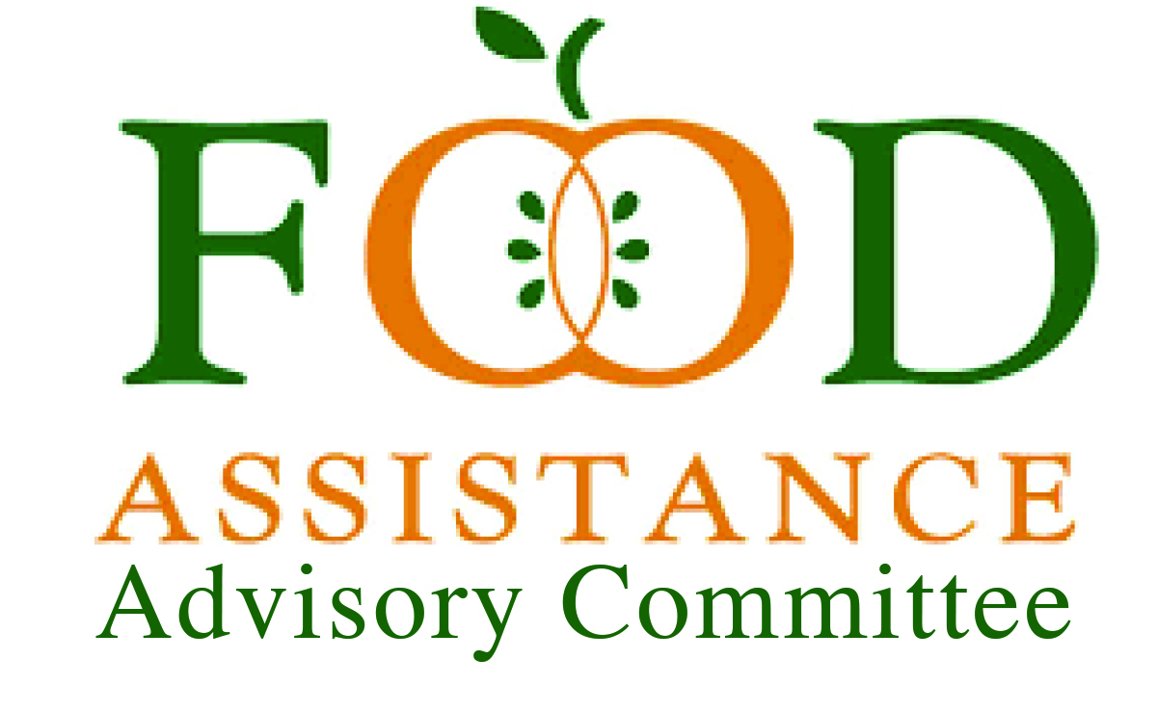
Food Assistance Advisory Committee Mtg
July 11, 2023 11:00 – 12:30 p.m.

AGENDA

11:00 Welcome–Please share your name & organization in chat.
Change your name on screen. Please have your screen on, if possible.
Need a secretary today!

11:05 Approval of Minutes – we’ll get the minutes out later this week.

11:10 Catch up on the past two quarters – Kim Eads

    - EFAP & Early Action funds
    - TEFAP
    - CCC Phase 1
    - Food Security
    - We Feed WA

      - Director’s Discretionary funds
    - Reserve warehouse
    - LFPA
    - Resiliency Grant

11:35 WSDA Updates – Kim Eads
Projections for 3 & 4 Quarters (July-December) -
EFAP
TEFAP
Farm to Food Pantry
Farm to Food Banks
11:55 Resources -
Getting connected - Trish
Harvest Against Hunger – David Bobanick
TEFAP Food – James Scovel
Food Lifeline and 2nd Harvest updates – Ryan Scott & Eric Williams

12:20 Advocacy Updates – NWH Farm Bill Presentation – Claire Lane

12:25 Good of the Order:
Contractor Calls – August 4th, 9 a.m.
General Focus Calls – July18th, 9 a.m.
WFC Board Meeting – July 26th 1-3:30 p.m.

Next FAAC meeting: October TBD

