Washington Food Coalition
www.wafoodcoalition.org
PO Box 95752
Seattle, WA 98145
phone: 206.729.0501
fax: 206.729.0504
info@wafoodcoalition.org

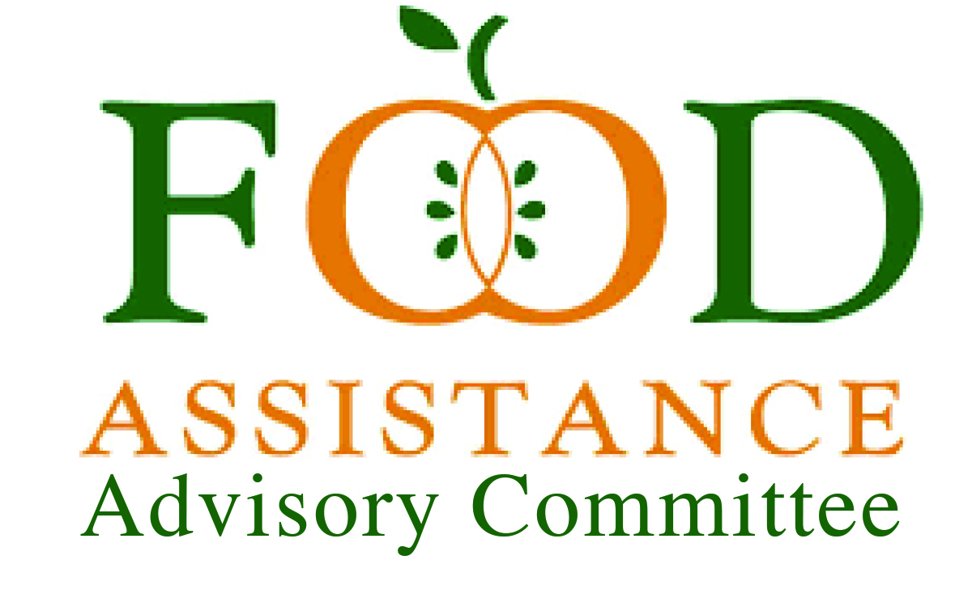Food Assistance Advisory Committee Mtg
June 25, 2024 9 to 10:30 a.m.

AGENDA

9:00 I. Welcome/Introductions–Please share your name & organization in chat.
Change your name on screen. Please have your screen on, if possible, for the first
15 minutes.

9:15 ll. Approval of Minutes – April 2024 meetings

9:20 III. Program Updates – What’s happening with your programs?
Are there topics you want to discuss or share at the next meeting?

9:40 lV. WSDA Updates – Kim Eads
    - What’s happening in the new fiscal year!
9:55 V. Committee Updates & Topics to Discuss:
A. FAA Committee Make-up
- Chair Position:
        - WFC Board member
        - Lead agency role, preferred
        - Committee of the WFC
- Community member involvement
- Statewide Representation (urban/rural)
- Tribal Representation
- Leads/Sub awardees representation
Who is missing?
B. Client Intake Committee: On hold
C. Nutrition Committee – Survey Results - Trish
D. Advocacy Committee – Farm Bill (Aaron & Claire)

10:25 VI. Good of the Order:
Contractor Calls –July 12, 9 a.m.
General Focus Calls –July 23rd, 9 a.m.
WFC Board Meeting – July 24th
WFC Conference – September 18-20th
10:30 Vl. Close

